**Compound Glyphs:**

Often it is convenient to combine some of glyphs in a font to produce new glyphs. This is commonly done to produce accented character in cases where the font includes both the base character and the accent character. TrueType allows for these combinations through the mechanism of compound glyphs. Some glyphs that might be created in this manner are shown in FIGURE 7.

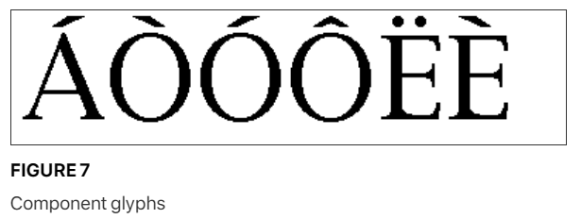

Compound glyphs consist of a base glyph and a second glyph that is added to produce new glyph. The new glyph combines the two components to create the new compound form. If desired, glyphs can be created using more than two components.

**Compound glyph placement:**

To aid in the placement of the additional glyphs relative to the base glyph, information must be provided specifying the offset to the subsequent glyphs from a point in the first glyph.

Each of the glyphs combined to form a compound glyph can be scaled by a different amount. This might be useful, for example, in creating fractions by combining the fraction glyph and two digits.

Each of the glyphs that make up a compound glyph can have associated instructions. The compound glyph as a whole can also have instructions.

A detailed description of the specification for compound glyphs is given in Compound glyphs (glyph table).

**The master grid:**

The points that make up a glyph outline specification are located on a grid whose units are indivisible and of a size defined by the creator of the font. These units are termed font-units.

The grid is a two-dimensional coordinate system whose x-axis describes movement in a horizontal direction and whose y-axis describes movement in a vertical direction. The grid origin has coordinates (0,0). The grid: sizegrid is not an infinite plane. Each point must be within the range -16384 through +16383 font-units.

In creating the glyphs outline, the font creator makes use of an imaginary square that derives from old typographic concept of the em square. This square can be thought of as a tablet on which the characters are drawn, although it is permissible for characters to extend beyond the tablet or em square. It is the size of the font-unit relative to the size of the em square that determines the granularity of the grid. In other words, the resolution of the grid is function of the number of font-units per em.

The greater the number of font-units per em, the greater subtlety of design that can be represented in the font file. In determining what is a suitable grid granularity, the font designer should take into account the maximum resolution of the potential output device and allow for possible loss of precision in data conversion. Outline scaling will be fastest if the units per em is a power of two. For example, the Apple core fonts are designed on a grid with 2048 units per em.

FIGURE 8 shows two different grids. The grid on the left cannot represent the subtlety of original design for the letter A. The grid on the right, with four times the number of units per em, comes closer, though a finer granularity is needed to faithfully render the original design.

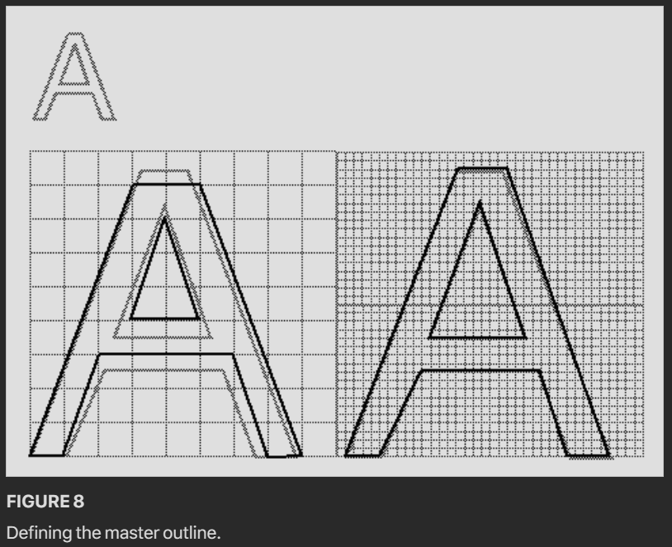

**Placing glyphs in the grid:**

The coordinates which define a glyph’s shape also determine that glyph’s placement relative to the coordinate grid. While there is no formal requirement that glyphs have a consistent relationship to the grid, in practice, applications depend upon the existence of some convention to aid the layout of text.

In Roman fonts, which are intended to be laid out horizontally, a y-coordinate of 0 typically corresponds to the baseline of the font. No standard meaning is associated with an x-coordinate of 0 but application will benefit it font foundries choose a standard meaning. A common convention is to place the glyph origin so that the value of the left edge of the glyph will equal the left side bearing. This option is illustrated in FIGURE 9. It is also possible to place the aesthetic center of glyphs at the x-axis as in FIGURE 10.

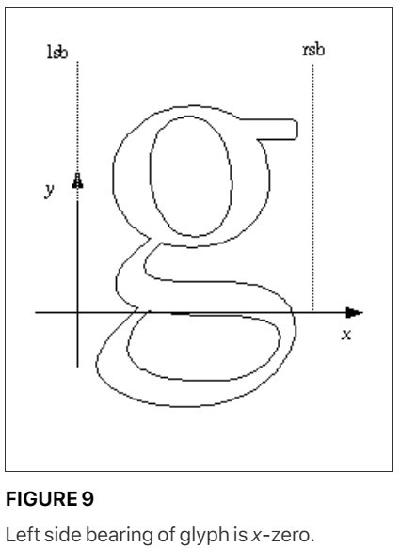

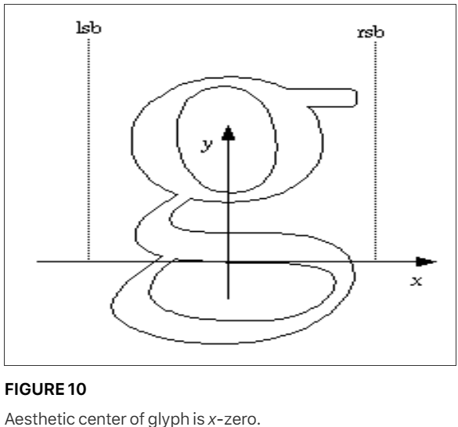

Another alternative is to place each glyph so that its leftmost extreme outline point has an x-value equal to the left-side-bearing of the glyph.

While in the days of metal type, the glyphs could not extend beyond the em square, digital typefaces are not so constrained as is illustrated in FIGURE 12. The em square may be made large enough to completely contain all glyph in a font, including accented glyphs. Or, if it proves convenient, portions of glyph may extend outside the em square. Since TrueType fonts can handle either approach, the choice depends upon the preference of the font manufacturer.

